“Knights Refrigeration presents
10th Portland Open Border Challenge”
Saturday 9 July 2022—10.00am

NON CONTACT ENTRY FORM

Venue: Portland Secondary College, Cnr Must & Fawthrop Streets, Portland

This entry form to be completed and received with entry fee by no later than 2 July 2022
All students to arrive by 9.30 in preparation for a Tournament march on.
First Name ............................................................................... Surname ...............................................................................
Address ...................................................................................................................................................................................
Contact Tel No ........................................................... D.O.B ......................................... Age (as at 9/7/2022)....................
Email ........................................................................................................................................................................................
Martial Art Style .................................................................Grade (kyu)...................................................................................
Dojo ...................................................................................... Instructor .................................................................................
Instructor Email……………………………….. ........................................................
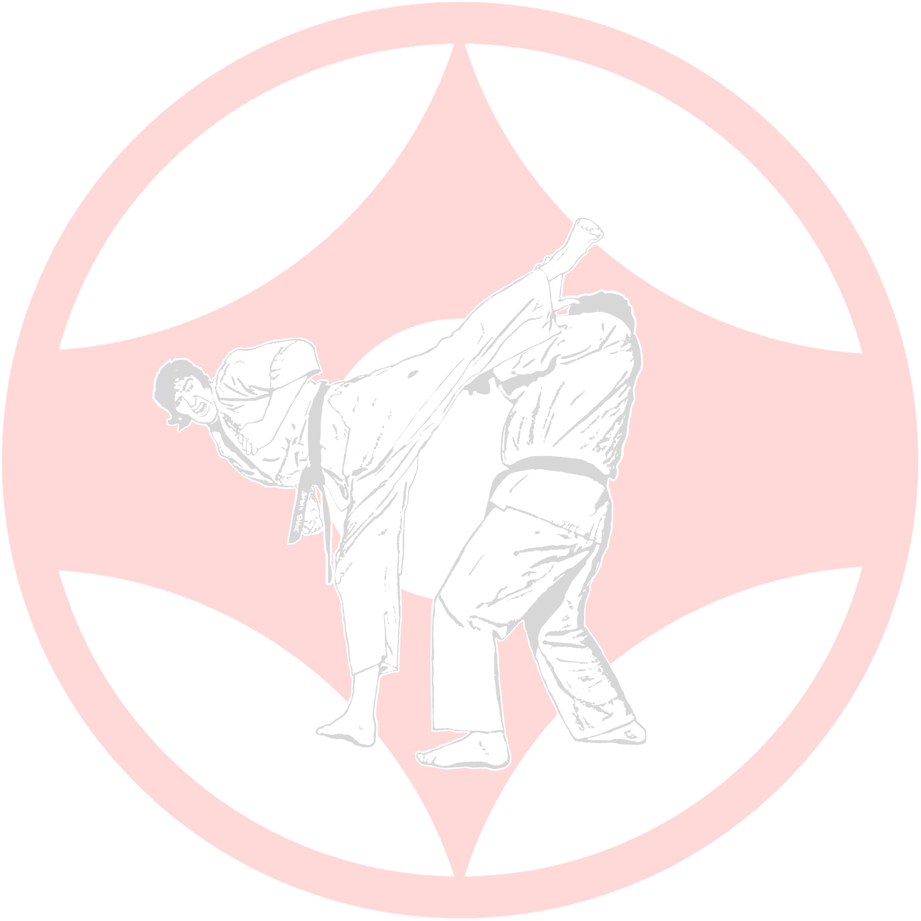
I wish to enter the following Non Contact Division:
□ Male Kumite □ Female Kumite □ Kick Start/Beginner
There will be a Veterans Division for 40 and over.
The organisers reserve the right to merge divisions.
Mouth guards are compulsory and to be provided by competitor.
Leg/instep protectors are optional.
Hand mitts are not permitted.
See your instructor for advice on proper selection of protective equipment.
The tournament will use a Repêchage system so all competitors will have a minimum of two bouts.
Kumite rules will follow the Victorian Kyokushin Karate Association Rules which are available on request by emailing Shihan Ron Jorgensen: rdjorgo@gmail.com
All competitors must report to their designated ring when advised and stay on that ring until medals are presented.
Assumptions of Risk and Release of Liability
I the undersigned, do hereby voluntarily submit my application for participation in the 2021 Non Contact Portland “Open Border Challenge” tournament. I assume full responsibility for any and all damages, injuries or losses of any kind that may occur whilst participating in this tournament. I agree to waive all claims and forever release the organisers, the promoters, participants, officials and sponsors from any injuries that I may sustain whilst participating in this tournament. I accept that any medical treatment on the day will be of a first aid basis only.

Signed (by Competitor) ............................................................................... (Parent/Guardian if U18) ............................. Date
Entry fee: $10.00 Please pay into this account Spectators: Adults $5 / Children u/16 $2

(Cameras & Video Cameras permitted).

BSB: 633000
Acct No: 142432913
Acct Name: Portland Kyokushin Karate Club

Further information may be obtained by telephoning Shihan Ron Jorgensen or Sempai Debbie Jorgensen – 0477 387 244

