“Knights Refrigeration present
10th Portland Open Border Challenge”
Saturday 9 July 2022—10.00am

MALE CONTACT ENTRY FORM

Venue: Portland Secondary College, Cnr Must & Fawthrop Streets, Portland

This entry form to be completed and received with entry fee by no later than 2 July 2022
All students to arrive by 9.30 in preparation for a Tournament march on.

First Name ............................................................................... Surname ...............................................................................
Address....................................................................................................................................................................................
Contact Tel No ........................................................... D.O.B ......................................... Age (as at 9/7/22 )....................
Email ........................................................................................................................................................................................
Martial Art Style..............................................................................................Dojo..................................................................
Instructor ...................................................................... Instructor email.................................................................................
Grade (kyu) ..................... Height (cm) .................... Expected Fighting Weight on day of tournament (kg) ....................
Full Contact Tournament History & placings (if more space needed write additional tournaments on back of page)
Tournament: ........................................................................................................ Year: ....................... Place: ......................
Tournament: ........................................................................................................ Year: ....................... Place: ......................
Tournament: ........................................................................................................ Year: ....................... Place: ......................
Tournament: ........................................................................................................ Year: ....................... Place: ......................
Tournament: ........................................................................................................ Year: ....................... Place: ......................
Tournament: ........................................................................................................ Year: ....................... Place: ......................
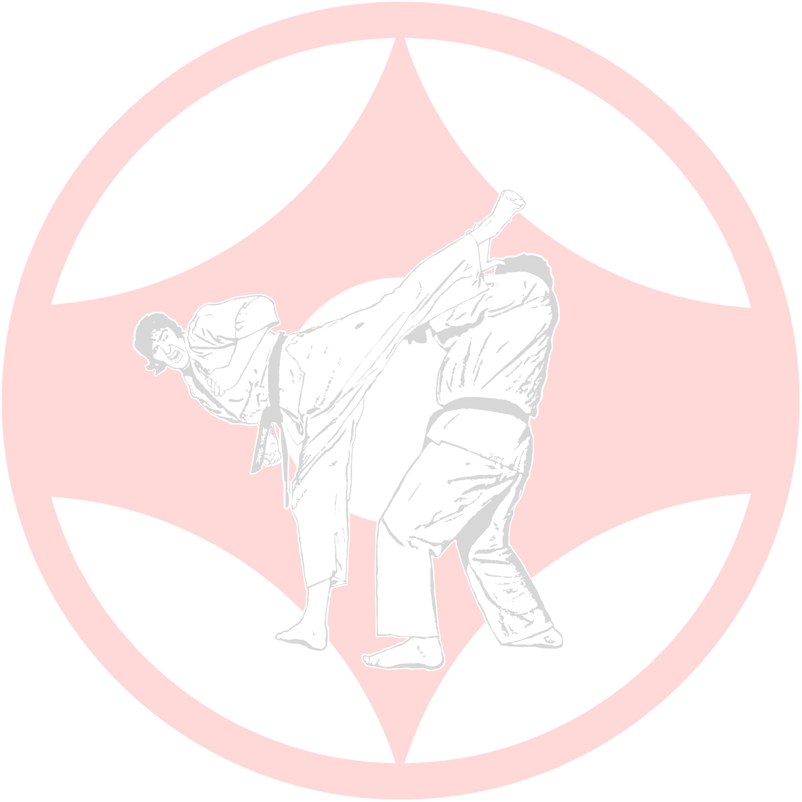
Tournament: ........................................................................................................ Year: ....................... Place: ...................... Tournament: ........................................................................................................ Year: ....................... Place: .....................
Featherweight | Lightweight | Middleweight | Heavyweight
□ Under 60.1 kg | □ 60.1–70 kg | □ 70.1–80 kg | □ 80.1 kg & above
Contact Divisions will be arranged by weight and grade:
Tick 1: □ Novice Contact* □ Full Contact** □ Veterans (40+) Novice* □ Veterans (40+) Full Contact**
Lightweight Middleweight Heavyweight Super Heavyweight
□ Under 70.1 kg □ 70.1–80 kg □ 80.1–90 kg □ 90.1 kg & above
* Novice Contact: Head guards (optional), 8 oz gloves are compulsory and will be provided by Tournament organisers. Shin, Mouth & Groin guards are compulsory and to be provided by competitor.
** Full Contact: Mouth & Groin guards are compulsory. 5th Kyu and below shin guards are optional. Protective equipment to be provided by competitor.
COLT Divisions □ 16–17 years □ 14–15 years
Head guards, 8 oz gloves & Body guards (14–15 years) are compulsory and will be provided by Tournament organizers. Shin & Mouth guards are compulsory and to be provided by competitor. Soft cup chest protectors are optional.

CONTACT ENTRY FORM

Page 2

All contact competitors will be required to weigh-in either on Friday evening from 5–7 pm at the Portland Dojo 28 Percy Street or on the day from 9.00 am at the venue.
Kumite rules will follow the Victorian Kyokushin Karate Association Rules which are available on request by emailing
Shihan Ron Jorgensen rdjorgo@gmail.com

All participants are required to have a signed Doctor’s permission letter to be presented at Weigh-in before being able to participate. A copy is on the website

All Colts and Novice Competitors are encouraged to bring their own head protection; gloves & body shields to limit spreading germs. If you do not have access to such equipment, the tournament will still supply these items and they will be sanitised between each round.

Assumptions of Risk and Release of Liability
I the undersigned, do hereby voluntarily submit my application for participation in the 2021 Portland “Open Border Challenge” tournament. I assume full responsibility for any and all damages, injuries or losses of any kind that may occur whilst participating in this tournament. I agree to waive all claims and forever release the organisers, the promoters, participants, officials and sponsors from any injuries that I may sustain whilst participating in this tournament. I accept that any medical treatment on the day will be of a first aid basis only.

Signed (by Competitor) ................................................................................................................ Date:………………….
Parent/Guardian print name: …………………………………………………………………………..
Signed (by Parent/ Guardian if U/18)…………………………………………………………………... Date…………………

Entry Fee: $20.00 Please pay into this account Spectators: Adults $5/ Children u/16 $2
(Cameras & Video Cameras permitted).
BSB: 633000 Acct No: 142432913 Acct Name: Portland Kyokushin Karate Club
Further information may be obtained by telephoning Shihan Ron Jorgensen or Sempai Debbie Jorgensen – 0477 387 244

